# NEWSLETTER

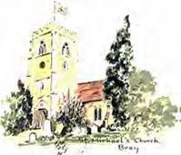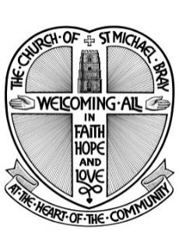

August 2024

# from the Church of St.

Michael’s Bray

The Parish Church of Bray with Braywood, Holyport & Moneyrow Green, Fifield, Touchen End and Oakley Green

website: [www.braystmichael.co.uk](http://www.braystmichael.co.uk/)

Dear Friends,

As the summer enters its final stages I hope you have had some holidays and fine weather. I see that the forecasters are saying we might have a heatwave in September!?!

You will see in this Newsletter that the church at Bray has supported several charities over the summer with its "Summer Teas" on Sunday afternoons. A big thank you to all who organised and supported these events. Our Jazz on the Lawn this year drew a big crowd (about 120+), thanks again for your support!

If you haven't had a holiday yet here are some thoughts to encourage you:

Taking a holiday is more than just a break from work; it’s essential for our well-being. Holidays can be "holy days" - a time for healing. Here are some key benefits:

**Stress Reduction**: Holidays provide a much-needed escape from daily stressors, allowing our minds and bodies to relax and rejuvenate.  
**Improved Mental Health**: Time away from routine can help reduce anxiety and depression, offering a fresh perspective and renewed energy.  
**Enhanced Productivity**: A well-rested mind is more creative and efficient. After a holiday, people often return to work with increased focus and motivation.  
**Strengthened Relationships**: Spending quality time with loved ones during holidays helps build stronger bonds and create lasting memories.  
**Personal Growth**: Exploring new places and cultures can broaden our horizons, fostering personal growth and a deeper understanding of the world.

In essence, holidays are a vital part of maintaining a balanced and fulfilling life. So, don’t hesitate to plan your next getaway! 🌴✨**Do you have any upcoming holiday plans? …/continued**

**Future dates:**

**Sunday School** - Sunday School during our 10.00 am service will resume on the first Sunday in September and will, initially operate on two Sundays a month.

**Service for children of all ages!** - Our next All Age service will take place on Sunday 15th September at 3.00 pm. Songs and stories for children of all ages, the service lasts about 30 minutes.

**Pet Blessing Service** - If you have a pet you can bring to church we are holding our first pet blessing service on Sunday 6th October at 3.00 pm. The service will include prayers by St Francis of Assisi (who especially loved all of God's creation) and songs with a special blessing of your pet! The service will last about 30 minutes but feel free to arrive or leave as needed!

Revd Canon Ainsley Swift

***A message from Bishop Olivia giving guidance on the safe receiving of Holy Communion:***

*Intinction (dipping the wafer in the cup) has been practiced by a few in the Church of England for a long time, and is very much discouraged by the Bishops as it should only ever be an exceptional practice.*

*The sharing of the common cup is one of the foundation stones of Anglican sacramental practice, dating back to Cranmer’s Prayer Book and part of our heritage, and which in normal times should be normal practice. Of course, during Covid many people became used to intincting, (as they did a few years ago during the Swine Flu epidemic), and there will be some who wish to continue with this because they are nervous about infection.*

*Of course, no one needs to drink from the chalice if they do not feel comfortable doing this, as receiving the bread alone is sufficient to receive the Sacrament. But for those who do wish to receive the wine, the common cup is there. Drinking from a silver vessel is extremely safe as germs do not survive contact with the metal for long and the chalice is always wiped.* ***I am now requesting that you cease to offer intinction as an option,***

Friends of St. Michael’s

Upcoming Events

**Bray Village Fete**

**Sunday 8th September 2024 : 11.00 am – 4.00 pm on Bray Village Green**

Please come and support the Friends of St Michael’s at their stall selling jigsaw puzzles and good quality second hand books. Also, hand-painted cards of the church by Felicity Abbott, a member of the congregation, and newly designed cards and tea towel, created especially for the Friends by Alice Proctor, a member of one of Bray village’s families. This delightful design is based on a stained glass window using ideas from windows around the church. A great Christmas stocking filler!

**Cash is essential** as we will not have access to a card machine.

We look forward to seeing you on the 8th.

**Talk by Hugo Vickers**

**Wednesday 9th October 2024 : 7.30 pm in St Michael’s Church**

Hugo Vickers is a renowned royal biographer and the title of this illustrated talk is “**Q2 to K3”** (Queen 2 to King 3). Hugo will talk about the transition in the monarchy from the late Queen Elizabeth II to King Charles III.

Tickets will be for sale from 1st September from Julie Graham ([julie.graham@brayclose.com](mailto:julie.graham@brayclose.com) or 01628 778054). Price £15.00 or £10 for Friends of St Michael’s.

**CHURCH TEAS**

In aid of various charities



Sunday 25th August and Sunday 1st September.

2.30pm to 5.00pm in St Michael’s Church Hall

Come and meet friends old & new

The bellringers were tea hosts on the gloriously sunny afternoon of Sunday 11 August. At Bray, we pride ourselves not only on our fine ring of bells, but also on a very strong sense of camaraderie among the team. With ages spanning 8-90-something, we are a sociable bunch, and pretty good bakers as well.

We provided a good range of homemade cakes and scones with all proceeds going to our chosen charity Thames Valley Adventure Playground for which we raised we raised £300. Most of our ringers were in attendance, serving, washing up, demonstrating handbell ringing and giving Tower Tours. The tours were very popular, with lots of visitors heading up to the ringing chamber made famous in the Midsomer Murders bellringing episode. For those who had not ventured up there before, it was a chance to watch bellringing, see the peal boards, ask lots of questions and even have a go. There was also an opportunity to go up to the viewing gallery, from which they could look down and see the bells from above. It's always quite startling to see just how big the bells are, and how sturdy the beams in the belfry are. The most intrepid visitors also went up on to the tower roof. On a clear sunny afternoon the views over the neighbouring cricket pitch, the Thames, Windsor Castle and of course Slough Trading Estate were clear.

Many thanks to all who supported this event. If anyone local is interested in coming up to have a look and find out more, or would be interested in learning to ring, come and see us on a Monday evening between 7:30 and 9, or email me, Maggie Ross, Tower Captain, on [maggieross@live.co.uk](mailto:maggieross@live.co.uk)

*Looking forward to seeing you*

**MAIDENHEAD FOODSHARE**

**Thank you**

Each year Maidenhead Foodshare launch an appeal for donations towards the extra food required by families in need, particularly those with children who are entitled to free school meals during term time. This summer Foodshare asked for supermarket vouchers and I am delighted to report that owing to the generosity of the congregation, £435 has been donated to date which will be an enormous boost to Foodshare's appeal! Thank you to all who have donated so generously! *Helen Pearson, Church Warden*

**School Holiday Food Support**

!

**Ride+Stride** is an annual nationwide sponsored church-crawl whereby you can visit as many (or as few) churches as you like on the second Saturday in September (the 14th September this year) between the hours of 10am and 6pm. The scheme is organised in this county by the Berkshire Historic Churches Trust which aims to raise funds to help with the cost of repairs to the fabric of Christian churches in the county.

If you should undertake a ride or stride, you would plan a route in advance and ask people to sponsor you per number of churches you visit.  Then on the day, you would walk, run, cycle, ride a horse or travel by boat between churches and look around them in the process.

If you would like to take on this challenge on behalf of St Michael’s Church, do contact me and I can explain things in more depth.  Meanwhile, you might like to have a look at the Berkshire Ride+Stride web site at <https://www.berkschurchestrust.org.uk/>.  Click on the Ride+Stride link for the drop down menu.

As riders and striders will be visiting our own church on the day, it would be nice to keep the church open, so later in the year, I shall be looking for volunteers to church sit and to welcome visitors.

You can contact me, Sarah Pallot, by email: [sarah.pallot1411@gmail.com](mailto:sarah.pallot1411@gmail.com) ;

or by phone:  01628 622716 or 07980 941883



**Sunday Afternoon Recitals**

**at 3.00pm**

**Retiring Collection and Afternoon Tea**

**8 September Annie Yim (piano)**

Hong Kong-born Canadian pianist Annie Yim

presents a programme to include **Debussy** and **Bach**

**13 October Riyad Nicolas (piano)**

Syrian-British pianist Riyad Nicolas presents unique

compositions for piano by Syrian composers

**10 November Peng Lin (piano)**

Award-winning Chinese pianist Peng Lin presents

Variations and Etudes of **Schumann** and **Scriabin**

**8 December Community Carol Concert**

Join us for this annual festive celebration of carols

and readings in aid of **Thames Valley Adventure Playground**

Our Director of Music, Oliver Gooch, will be conducting the The Royal Philharmonic Concert Orchestra, The London Philharmonic Choir and The Bach Choir in a performance of Beethoven’s Ninth at The Royal Albert Hall on Saturday 21st September.

Our Director of Music, Oliver Gooch, will be conducting the The Royal Philharmonic Concert Orchestra, The London Philharmonic Choir and The Bach Choir in a performance of Beethoven’s Ninth at The Royal Albert Hall on Saturday 21st September.

**Music at Bray**

**Jazz on the Vicarage Lawn**

Sunday 28 July gave us a bright and warm afternoon, with neither the pouring rain nor overpowering heat and humidity that seem to have characterized this summer. Just right, then for our annual visit to the vicarage garden, for a relaxing and entertaining time listening to a selection of jazz numbers in the New Orleans style from the excellent Josephine Davies Quartet

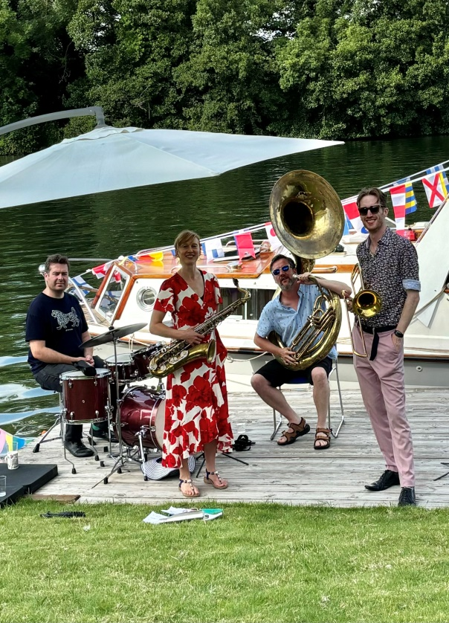

We were delighted that Josephine was able to come to Bray, as she has done in each of the last ten years or more, and we weren’t disappointed.

We enjoyed a wide range of tunes, excellent musicianship all round, and a good smattering of vocalisation. An audience of well over one hundred attended, with a resultant profit of £600, which Music at Bray has donated to the church.

Grateful thanks, as always, are due to Ainsley and Jane Swift for having us.

***Jim Tucker***

Members of the choir gathered at the house of Ollie and Becky Gooch to say farewell to Mike and Vicki Henley. Vicki joined the choir just after I did, 25 years or more ago, and her wonderful soprano singing has been a highlight ever since. Nowadays she is also a valued member of the finance team, looking after Gift Aid for the PCC. Mike came into the ranks of the tenors a bit later and was then confirmed by the current Archbishop of York. Mike’s exploits working with Ian Murray on the fabric of the church are legendary; the church’s gutters have never been cleaner. It would take too long to mention all that they have done, but of course we will remember them more for what they have been, and are, good friends to so many of us. I remember John as a little boy, starting at Desborough with a school bag bigger than him, I also recall Thomas as a toddler in a buggy, now in a process of discernment, with a view to becoming an Ordinand.

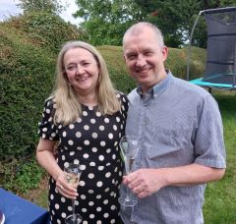

Thank you, Mike and Vicki, for all that you have done and all that you have been. We pray for God’s blessing on your adventure to the north of Scotland. Please don’t forget us, we certainly won’t forget you.

*Jim Tucker*

The July Issue of the Newsletter reported on Andy Medlicott’s ordination as a Deacon in the Church of England at Christ Church Cathedral, Oxford, on Saturday 29th June.

If you would like to view a recording of the service then here is the link

<https://www.youtube.com/live/RzdxbYQW58s>

**CONTACT LIST**

**The Vicar**: Rev. CanonAinsley Swift 633113

**Curate**: Rev’d Andy Medlicott andymed256@gmail.com

**For general enquiries (Christenings, Weddings etc) in the first instance please contact our Parish Administrator, Richard Severn: 01628 633113** [**stmichaelsbray@gmail.com**](mailto:stmichaelsbray@gmail.com)**"**

|  |  |
| --- | --- |
| **The Churchwardens:** |  |
| Helen Pearson | 07979 756409 |
| Lynn Olney | 07966906092 |
| **Deputy Churchwardens:** |  |
| Jim Tucker | 673685 |
| Penny Murray | 623041 |
| Mary Wiles | 635000 |
| **Sacristan & Lay Funeral Minister**: |  |
| Lynda Jones | 635178 |
| **Verger**: Jim Tucker | 673685 |

**Parochial Church Council:**

**Hon Secretary:**

Katrin Brunning: [katrin.brunning@btinternet.com](mailto:katrin.brunning@btinternet.com)

##### Hon Treasurer:

Richard Severn [richarddb7@outlook.com](mailto:richarddb7@outlook.com)

|  |  |
| --- | --- |
| **Gift Aid Officer :** |  |
| Vicki Henley |
| [vicki@henleyclan.co.uk](mailto:vicki@henleyclan.co.uk)  **Electoral Roll Officer:** |
| Penny Murray |
| **Director of Music:** |
| Oliver Gooch |
| **Assistant Director of Music:** |
| Lindsay Bramley |
| **Parish Safeguarding Officer/Sunday School:** |
| Natasha Teeder | 674469 |
| **Bellringers:** |  |
| *Tower Captain:* |  |
| Maggie Ross  maggieross@live.co.uk |  |
| **Friends of St. Michael’s** |  |
| Lynda Jones | 635178 |
| **Church Flowers:** Maggie Jans | 635732 |
| **Holyport School Headteacher:** |  |
| Mrs Amanda Featherstone | 627743 |
| [https://www.holyportprimaryschool.co.uk](https://www.holyportprimaryschool.co.uk/) |  |
| **Braywood School Headteacher:** |  |
| Mrs Susan Calvert | 623660 |
| [https://braywood-ce.eschools.co.uk](https://braywood-ce.eschools.co.uk/) |  |