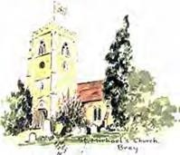
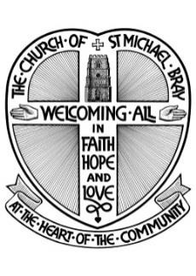
NEWSLETTER
October 2025

from the Church of St.
Michael’s Bray

The Parish Church of Bray with Braywood, Holyport & Moneyrow Green, Fifield, Touchen End and Oakley Green
website: www.braystmichael.co.uk

Dear Friends,

As I write this, Autumn is taking hold, leaves are beginning to fall; “You crown the year with your goodness, and you give us the fruits of the earth in their season” as the Collect for Harvest says.
We come this month to what has become our annual “Generous Giving Sunday” sometimes called Stewardship Sunday when we humbly ask if you will consider your commitment to the financial support of St Michael’s church. Please give as generously as you are able.
As the seasons change so the Church year rolls into the season of Remembrance; not only Remembrance Sunday itself (this year on Sunday 9th November), but also All Souls Day when we give thanks and remember the ‘faithful departed,’ those we have loved and see no longer (this year on Sunday 2nd Nov at 4.00 pm). We also are preparing for Advent and the new Church year as we keep the Sundays of the Kingdom season leading up to the Feast of Christ the King 23th November.
As we prepare for Advent; a time of reflective preparation, we welcome back Canon John White (late of St George’s Chapel, Windsor) who will lead four discussion sessions on the theme “Living with difference.” The first session is on Saturday Nov 1st at 3.00 pm and the venue is the Reading Room at Jesus Hospital (if you are interested in attending please let me know and I can explain how you get there!). There will be 4 sessions in total; 1st, 8th, 15th, and 22nd November and the venue will move around the village; stay in touch for venue information.
You will find more details of other upcoming services and events elsewhere in this edition of the Newsletter.

With best regards
Rev’d Ainsley

GENEROUS GIVING SUNDAY 2025

Generous Giving Sunday, following as it does the traditional Harvest Festival, has a number of objectives, and the first, always, is to celebrate and give thanks for the wonderful financial contributions to the Lord’s ministry in our parish made by the congregation. In 2024 the total of receipts from the Parish Giving Scheme PGS, Gift Aid, standing order payments, cash collections and contactless payments came to around £88,000; the Parish Giving Scheme receipts are showing an increase this year of 5%, but overall it is hard to see the church’s general funding being in surplus this year. The church enjoys several other sources of modest income, fees in certain circumstances and property rent, as well as occasional generous donations, so that in 2024 the total for incoming funds was £105,000 or so, with a broadly similar amount predicted for 2025.
We rightly give thanks to God for blessing St Michael’s in this, and in so many other ways. But what we must not do is close our eyes to the ever-growing financial liability that faces a parish like ours. Based on our experience last year, and so far in this one, we can expect the following to be paid from general funds in 2026;
Heating and lighting | £6,000
Music | £7,000
Clergy expenses | £6,500
Parish share | £78,000
Administration | £9,000
Other expenses | £10,000
Total | £116,500
These figures are all approximate estimates, of course, but it is clear that we are close to finding ourselves in financial difficulty, given the general level of inflation at the moment.
Parish share is an emotive topic, which is not surprising given the amount due each year. There is a common misconception that we are somehow being asked to subsidise the Diocese of Oxford, and what folk see its ever-expanding
…/continued

workforce. The reality is that yes, we are contributing to the diocesan budget, but the vast majority of what we pay is for the benefit of the parish, covering as it does the cost of clergy – stipend (salary), pension, income tax and National Insurance, and of course housing. It also goes towards paying for all the support services, such as personnel and training, Premises Department, and administration generally. An excellent and full explanation of parish share can be found on the diocesan website at on-the-money.pdf .
This year we are taking a slightly different approach to Generous Giving Sunday, which is 19 October. As always, we invite you to review your giving if you are able, by increasing the monthly amount you send through the Parish Giving Scheme, or to join the scheme, or through whatever way you contribute to St Michael’s. In addition, we are calling that Sunday a Gift Day; please bring to St Michael’s, or at any time after that, one of the white “Gift Aid” envelopes which are always in the pews. Please complete with your details, with cash or cheque inside. If you would prefer to give something through the bank, please write “BANK” as well on the envelope. The details you will need are;
Account name | St Michael’s Bray with Braywood Parochial Church Council
Sort code | 203883
Account number | 80775754
So why give? At the heart of the Christian faith is the generosity of the self-giving God who entered the world to save humankind for a relationship with himself. God give his own life, through his Son, so that we can be forgiven and blessed. Please consider your response not only in the light of our financial needs but in response to the wonderful provision our God’s love for us.

Take my love; my Lord, I pour
At Thy feet its treasure-store.
Take myself, and I will be
Ever, only, all for Thee.

Jim Tucker

Pets Service - 2025

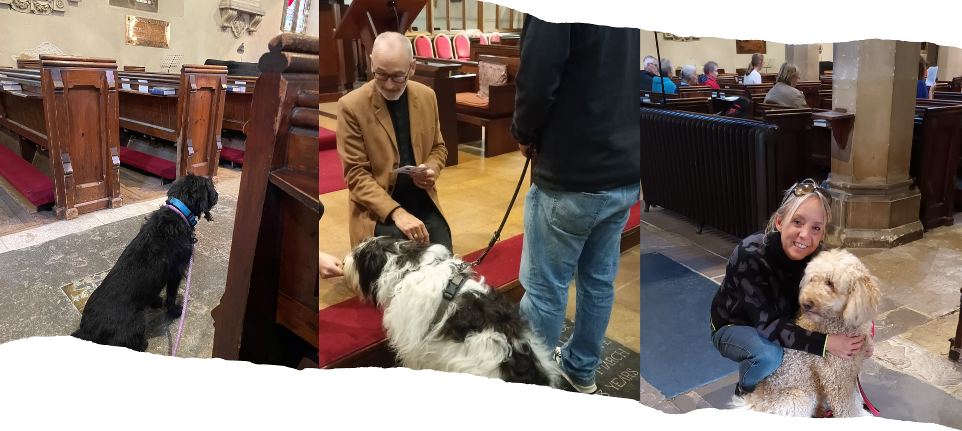
It was back again this year by popular demand… 17 dogs, 5 quails and a tortoise brought their humans along and enjoyed singing hymns, receiving a blessing and of course many were sniffing and enjoying a treat or two.

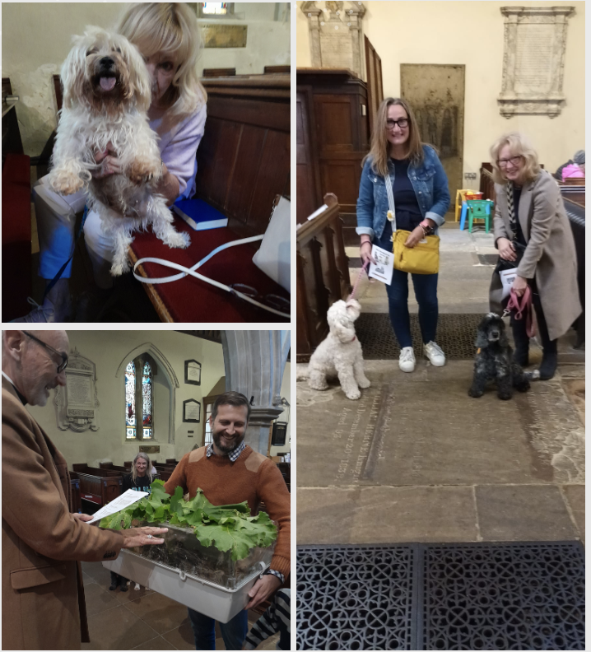
Pets are a huge part of the family, and it is good to acknowledge that, to give thanks for their friendship and love, and to remember those which are no longer with us but still in our thoughts. Doing so at the beginning of October coincides with World Animal Day and the feast day for Saint Francis of Assisi, the patron saint of animals!

Rather than lots of words… best to see a few of the photos from the day… please send any suggested captions to me at andymed256@mail.com

Take care & God Bless

Rev’d Andy Medlicott

Sunday Afternoon Recitals at 3.00pm

9 November Kapsetaki Piano Duo

Greek twin sisters, Stephanie and Marianna, perform music for piano duet including Schumann, Liszt, Grieg and Rachmaninoff

14 December Community Carols

Join us for this annual festive celebration of carols and readings in aid of Alexander Devine Children’s Hospice Service

Retiring Collection and Afternoon Tea

Services and Events at St. Michael’s

Taizé service November 23 at 4pm.
November 2 at 4pm, All Souls service, a time to remember and give thanks for the lives of those we have loved and lost.
November 9 at 10.45am, our annual Remembrance service to honour those who have served and sacrificed for our country.
Christmas Craft Fair 15th November 10.30 am to 2.30 pm
November 29 at 3pm, Christingle service. A wonderful family event that helps children understand the story of Jesus as the light of the world.
November 30 at 6pm, Advent Service of Light, a special evening celebrating the promise of the coming into the world of the light of Christ.
Community Carols on December 14 at 3pm,
Carol service on December 21 at 4pm, where we will sing traditional Christmas carols by candlelight.
Christmas Eve Crib service at 3pm is perfect for families with young children, telling the nativity story in a simple and engaging way. Midnight Mass starting at 11.30pm,
On Christmas morning, two services: Holy Communion at 8am and Christmas Communion at 10am.
We'll start the new year with a moment of reflection and hope with our Prayers for the year on January 1 at 3pm.

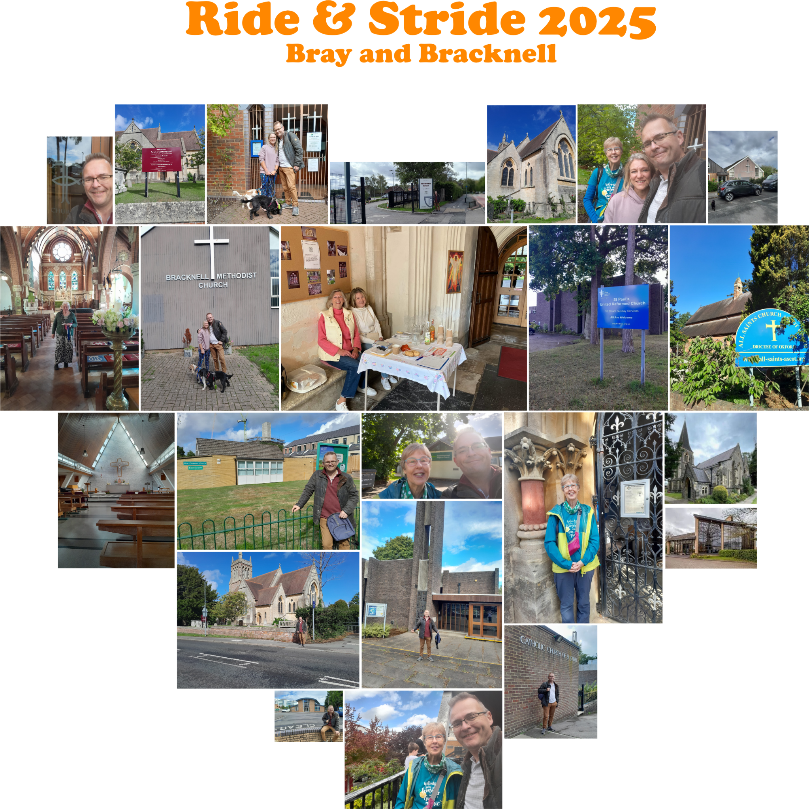

Saturday 12th September was Ride and Stride day where people visit as many churches by either walking or riding - raising money for both St Michael’s and Berkshire Historic Churches Trust. I set off from Ascot toward Bracknell to see how many I could visit… Beryl Maw joined me in Easthampstead which made for lovely company! Over about 7 miles I managed to visit these churches:
- All Saint's Church, Ascot (9:52am)
- St Paul's Church, Harmanswater (10:42am)
- Easthampstead Baptist Church, Easthampstead (11:07am)
- St Michael's Church, Easthampstead (11:20am)
- New Covenant Church, Bracknell (11:50am)
- Kerith Center, Bracknell (12:02pm)
- Holy Trinity Church, Bracknell (12:10pm)
- St Joseph's Catholic Church, Bracknell (12:52pm)
- Bracknell Methodist Church, Priestwood (1:15pm)
- St Andrew's Church, Priestwood (1:42pm)
All Saints was a good start (I have taken a service there recently too!) and they were open mainly for the Heritage day. Moving onto St Paul's, which was open but for a 'DIY day' to tidy up the church grounds as they were welcoming a new minister next week... however they were very hospitable, offered refreshments and were happy to talk about the history of the building!

…../continued

Sadly St Michael's in Easthampstead was not open (I'd not expected the Baptist church to be so) but nevertheless it was lovely to see and to see the parish rooms and how extensive the setup is there! The next few churches were also closed, as they were not really 'historic' so probably wouldn't have thought about Ride and Stride. It didn't stop us praying blessings over them as we passed and took photos!

We had a lovely time at Holy Trinity with a cuppa and lots of conversation.

St Joseph's was beautiful, a 1970's Scandinavian style church which Beryl felt very at home in as it was similar to a church in her past! It has a lovely atmosphere.

Walking to St Andrew's, via the Methodist church (which had an African party/gathering happening so we decided to not gatecrash), we passed pretty much by my house. St Andrew's was closed which was disappointing as I thought it might be open (I took a service there last week). It's a special place for me as Becky and I led it for 7 years, and I received the call to ordained ministry while serving there.

It was lovely to walk around, take the time to enjoy the sun, to think of all those places of worship - and those who worship in them!

Thank you everyone who sponsored me, we raised over £500 in the end!

Rev’d Andy
CONTACT LIST

The Vicar: Rev. Canon Ainsley Swift 633113
Curate: Rev’d Andy Medlicott andymed256@gmail.com
For general enquiries (Christenings, Weddings etc) in the first instance please contact our Parish Administrator, Richard Severn: 01628 633113 stmichaelsbray@gmail.com

The Churchwardens:
Helen Pearson | 07979 756409
Lynn Olney | 07966906092
Deputy Churchwardens:
Jim Tucker | 673685
Penny Murray | 623041
Mary Wiles | 635000
Sacristan & Lay Funeral Minister:
Lynda Jones | 635178
Verger: Jim Tucker | 673685

Parochial Church Council:
Hon Secretary:
Katrin Brunning: katrin.brunning@btinternet.com

Hon Treasurer:
Richard Severn richarddb7@outlook.com

Gift Aid Officer :
Vicki Henley
vicki@henleyclan.co.uk
Electoral Roll Officer:
Penny Murray
Director of Music:
Oliver Gooch
Assistant Director of Music:
Lindsay Bramley
Parish Safeguarding Officer/Sunday School:
Natasha Teeder | 674469
Bellringers:
Tower Captain:
Maggie Ross
maggieross@live.co.uk
Friends of St. Michael’s
Lynda Jones | 635178
Church Flowers: Maggie Jans | 07774484308
Holyport School Headteacher:
Mrs Amanda Featherstone | 627743
https://www.holyportprimaryschool.co.uk
Braywood School Headteacher:
Mrs Annie Cole | 623660
https://braywood-ce.eschools.co.uk

